**DS Lab Experiment - 8**

**Shashwat Tripathi**

**D20A 64**

**AIM:** To implement RNN Deep Learning Applications like Image Caption generator.

# THEORY:

A Recurrent Neural Network (RNN) is a type of neural network designed specifically to handle sequential data, where the output depends not only on the current input but also on the previous inputs in the sequence. Unlike traditional feedforward neural networks, RNNs have connections that form cycles, allowing them to maintain a "memory" of previous inputs, making them

well-suited for tasks involving sequences, such as time series prediction, natural language processing, and speech recognition.

Key Features of RNNs:

* Memory: RNNs have internal states (often referred to as hidden states) that retain information from previous time steps, giving the network a form of memory. This is especially useful for tasks where context is important, such as generating sentences or analyzing time-based data.
* Recurrent Connections: Each neuron in an RNN is connected not only to the next layer but also to itself, which allows the network to pass information across time steps. This enables RNNs to model dependencies in sequences.
  + Weight Sharing: The weights used to process input data are shared across all time steps, making the network efficient when handling variable-length sequences.

Implementation of RNN Deep Learning Applications: Image Caption Generator The task of generating captions for images involves combining computer vision and natural language processing (NLP), leveraging both convolutional neural networks (CNNs) and recurrent neural networks (RNNs). In this context, a Image Caption Generator system uses a pre-trained CNN, such as VGG16 or ResNet, to extract visual features from an image, which are then fed into an RNN (typically an LSTM or GRU) to generate a sequence of words that form a caption.

# CODE :

**Step 1 : Import the required libraries**

# linear algebra import numpy as np

# data processing, CSV file I / O (e.g. pd.read_csv) import pandas as pd

import os

import tensorflow as tf

from keras.preprocessing.sequence import pad_sequences

from keras.preprocessing.text import Tokenizer from keras.models import Model

from keras.layers import Flatten, Dense, LSTM, Dropout, Embedding, Activation from keras.layers import concatenate, BatchNormalization, Input from keras.layers.merge import add

from keras.utils import to_categorical, plot_model

from keras.applications.inception_v3 import InceptionV3, preprocess_input import matplotlib.pyplot as plt # for plotting data

import cv2

# Step 2: Load the descriptions

def load_description(text): mapping = dict()

for line in text.split("\n"):

token = line.split("\t")

if len(line) < 2: # remove short descriptions continue

img_id = token[0].split('.')[0] # name of the image

img_des = token[1] # description of the image if img_id not in mapping:

mapping[img_id] = list() mapping[img_id].append(img_des)

return mapping

token_path = '/kaggle / input / flickr8k / flickr_data / Flickr_Data / Flickr_TextData / Flickr8k.token.txt'

text = open(token_path, 'r', encoding = 'utf-8').read() descriptions = load_description(text) print(descriptions['1000268201_693b08cb0e'])

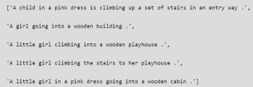

# Step 3: Cleaning the text

def clean_description(desc):

for key, des_list in desc.items():

for i in range(len(des_list)): caption = des_list[i]

word.isalpha()]

caption = [ch for ch in caption if ch not in string.punctuation] caption = ''.join(caption)

caption = caption.split(' ')

caption = [word.lower() for word in caption if len(word)>1 andcaption = ' '.join(caption) des_list[i] = caption

clean_description(descriptions) descriptions['1000268201_693b08cb0e']

# Step 4: Generate the Vocabulary

def to_vocab(desc):

words = set()

for key in desc.keys():

for line in desc[key]:

words.update(line.split())

return words

vocab = to_vocab(descriptions)

# Step 5: Load the images

import glob

images = '/kaggle / input / flickr8k / flickr_data / Flickr_Data / Images/'

# Create a list of all image names in the directory img = glob.glob(images + '*.jpg')

train_path = '/kaggle / input / flickr8k / flickr_data / Flickr_Data / Flickr_TextData / Flickr_8k.trainImages.txt'

train_images = open(train_path, 'r', encoding = 'utf-8').read().split("\n") train_img = [] # list of all images in training set

for im in img:

if(im[len(images):] in train_images): train_img.append(im)

# load descriptions of training set in a dictionary. Name of the image will act as ey def load_clean_descriptions(des, dataset):

dataset_des = dict()

for key, des_list in des.items(): if key+'.jpg' in dataset:

if key not in dataset_des: dataset_des[key] = list()

for line in des_list:

desc = 'startseq ' + line + ' endseq'

return dataset_des

dataset_des[key].append(desc)

train_descriptions = load_clean_descriptions(descriptions, train_images) print(train_descriptions['1000268201_693b08cb0e'])

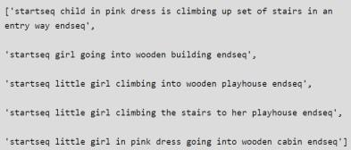

# Step 6: Extract the feature vector from all images

from keras.preprocessing.image import load_img, img_to_array def preprocess_img(img_path):

# inception v3 excepts img in 299 * 299 * 3

img = load_img(img_path, target_size = (299, 299)) x = img_to_array(img)

# Add one more dimension

x = np.expand_dims(x, axis = 0) x = preprocess_input(x)

return x

def encode(image):

image = preprocess_img(image) vec = model.predict(image)

vec = np.reshape(vec, (vec.shape[1])) return vec

base_model = InceptionV3(weights = 'imagenet')

model = Model(base_model.input, base_model.layers[-2].output) # run the encode function on all train images and store the feature vectors in a list encoding_train = {}

for img in train_img: encoding_train[img[len(images):]] = encode(img)

# Step 7: Tokenizing the vocabulary

# list of all training captions all_train_captions = []

for key, val in train_descriptions.items(): for caption in val:

all_train_captions.append(caption)

# consider only words which occur atleast 10 times vocabulary = vocab

threshold = 10 # you can change this value according to your need word_counts = {}

for cap in all_train_captions: for word in cap.split(' '):

word_counts[word] = word_counts.get(word, 0) + 1

vocab = [word for word in word_counts if word_counts[word] >= threshold]

# word mapping to integers ixtoword = {}

wordtoix = {}

ix = 1

for word in vocab: wordtoix[word] = ix ixtoword[ix] = word ix += 1

# find the maximum length of a description in a dataset max_length = max(len(des.split()) for des in all_train_captions) max_length

# Step 8: Glove vector embeddings

X1, X2, y = list(), list(), list()

for key, des_list in train_descriptions.items(): pic = train_features[key + '.jpg']

for cap in des_list:

seq = [wordtoix[word] for word in cap.split(' ') if word in wordtoix] for i in range(1, len(seq)):

in_seq, out_seq = seq[:i], seq[i]

in_seq = pad_sequences([in_seq], maxlen = max_length)[0] out_seq = to_categorical([out_seq], num_classes = vocab_size)[0]

# store X1.append(pic) X2.append(in_seq)

y.append(out_seq) X2 = np.array(X2)

X1 = np.array(X1) y = np.array(y)

# load glove vectors for embedding layer embeddings_index = {}

golve_path ='/kaggle / input / glove-global-vectors-for-word-representation / glove.6B.200d.txt' glove = open(golve_path, 'r', encoding = 'utf-8').read()

for line in glove.split("\n"): values = line.split(" ") word = values[0]

indices = np.asarray(values[1: ], dtype = 'float32') embeddings_index[word] = indices

emb_dim = 200

emb_matrix = np.zeros((vocab_size, emb_dim)) for word, i in wordtoix.items():

emb_vec = embeddings_index.get(word) if emb_vec is not None:

emb_matrix[i] = emb_vec emb_matrix.shape

# Step 9: Define the model

# define the model

ip1 = Input(shape = (2048, )) fe1 = Dropout(0.2)(ip1)

fe2 = Dense(256, activation = 'relu')(fe1) ip2 = Input(shape = (max_length, ))

se1 = Embedding(vocab_size, emb_dim, mask_zero = True)(ip2) se2 = Dropout(0.2)(se1)

se3 = LSTM(256)(se2)

decoder1 = add([fe2, se3])

decoder2 = Dense(256, activation = 'relu')(decoder1)

outputs = Dense(vocab_size, activation = 'softmax')(decoder2) model = Model(inputs = [ip1, ip2], outputs = outputs)

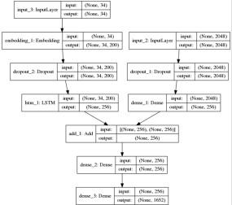

**Step 10: Training the model** model.layers[2].set_weights([emb_matrix]) model.layers[2].trainable = False

model.compile(loss = 'categorical_crossentropy', optimizer = 'adam') model.fit([X1, X2], y, epochs = 50, batch_size = 256)

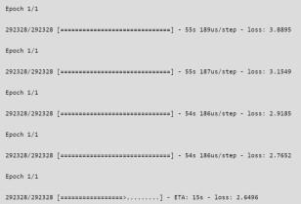

# Step 11: Predicting the output

def greedy_search(pic): start = 'startseq'

for i in range(max_length):

seq = [wordtoix[word] for word in start.split() if word in wordtoix]

seq = pad_sequences([seq], maxlen = max_length) yhat = model.predict([pic, seq])

yhat = np.argmax(yhat) word = ixtoword[yhat] start += ' ' + word

if word == 'endseq': break

final = start.split() final = final[1:-1] final = ' '.join(final) return final

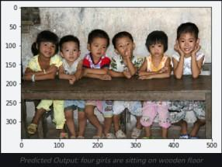

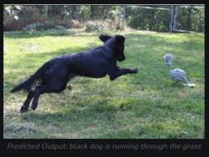

# CONCLUSION :

implemented a simple image caption generator model using an LSTM-based Recurrent Neural Network. The model was trained on a small dataset to predict the image caption.